Git and GitHub Desktop Version Control

Overview Version Control with Git and GitHub
Using Git and GitHub
Part 1: Set up git and a github repository
Part 2: Ignore files that shouldn’t be backed up
Part 3: Organize in Folders
Git and GitHub Resources

Overview Version Control with Git and GitHub
Git and GitHub are important elements of the professional software development world with version control tools that help individuals and teams of developers manage public open-source projects and private projects. You will be introduced to Git as a version control tool and GitHub server to store your versioned files. Explore the slides on Version Control with Git and Backing up with Github using Github Desktop

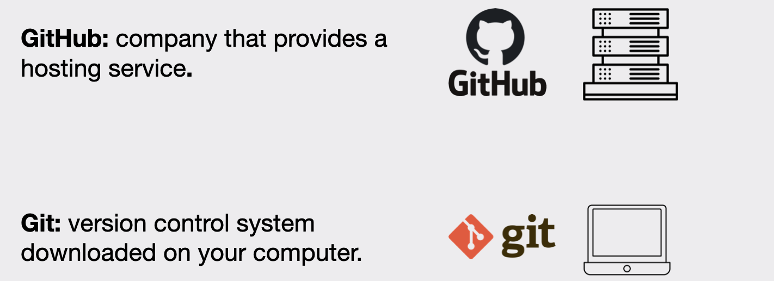

Using Git and GitHub
The following will help you set up Git and Github where you will use GitHub Desktop to manage versions of your code just like some developers in industry. You’ll commit your changes locally and push them to the cloud for backup.

Take your time reading instructions so you do not need to do it over. Going slow now can save time later.

Part 1: Set up git and a github repository
First you will set up a git and github repository using github desktop to manage your versions and back ups.

- Create a folder GitHubRepos for your github repositories. It is best to not put in your one drive or icloud drive or google drive folders. See below
  - On windows, put it in your C drive.
  - On Mac, put it in your Home folder
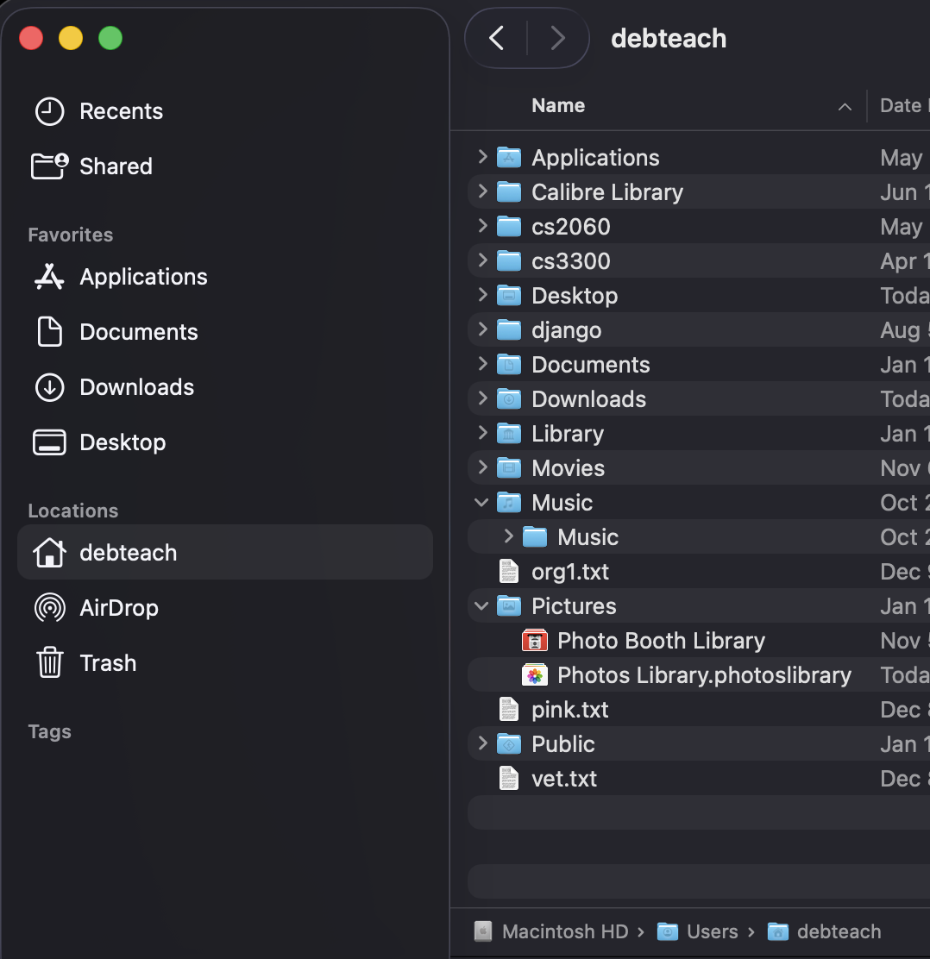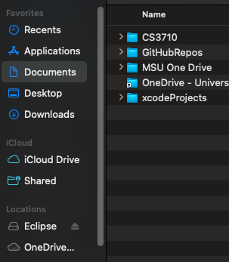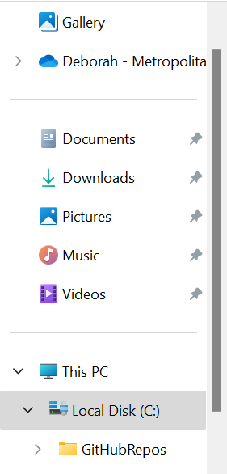
Put here
Windows
Mac
Do not put here
Do not put here
Put here

- Create a free GitHub account if you do not have one. Select Join for free. Follow the prompts to create your personal account or organization. You may want to use your personal email rather than your school email. You will need to verify your email.
- After verifying your email you can set up your account. There may be some questions to answer. Do not worry if you are not sure what they are asking. You can just answer what is required.
- Before you download some tools, you must know your operating system architecture. Read Determine Operating System and Architecture
- Download the correct GitHub Desktop.
- There are different types of files when downloading tools to install, such as Zip Files, Windows exe File, Mac DMG Files. Double-click to open.
  - Mac: after you open the zip file, you will see GitHub Desktop.app.
    - Double-click it and click open 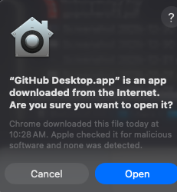
    - Next you will see this dialog and click Move and Restart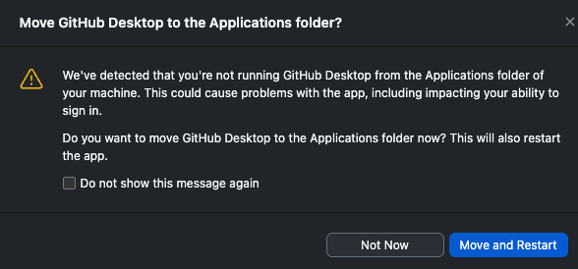
  - Windows: Double click to open Github Desktop that you downloaded
- Now that the app is open you can Add to Toolbar for Easy Access
- Next you need to create a new repository on your local Drive. Where this is located can be different if you already use git. You might see the following:
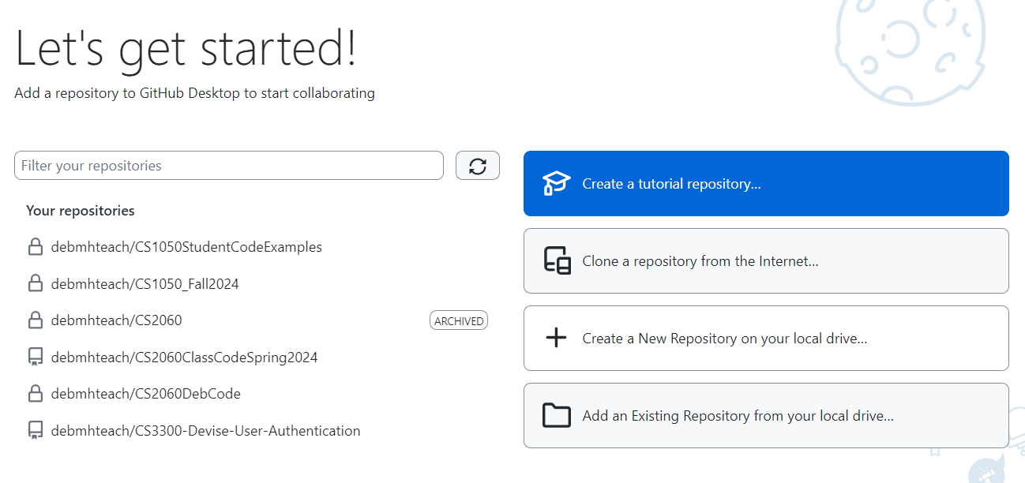

Or you might need to click add button and select Create a New Repository

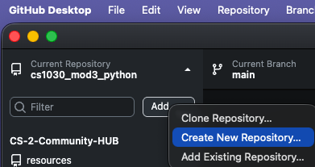

- Fill information to create a repository. Note: this is setting up the Git ignore to work with Java files
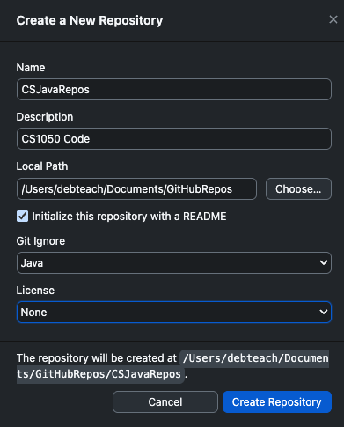

Name the repository and give a description
Choose GitHubRepos folder you created above on your local computer
Check
Select Java
Click Create
Setting up a GitHub Repository - A local repository using git has just been created on your computer.
- Read the information about publishing your repository and click Publish Repository.
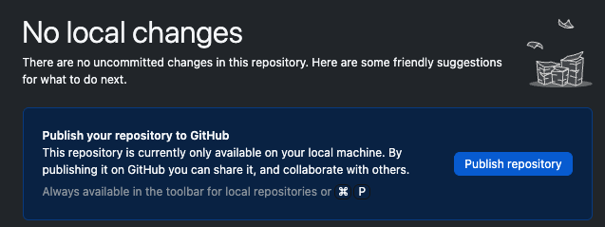

- Keep this code private so you are not sharing your solutions with others for this class. Click Publish Repository. After you finish the class you can make it public to share when interviewing for jobs or internships.
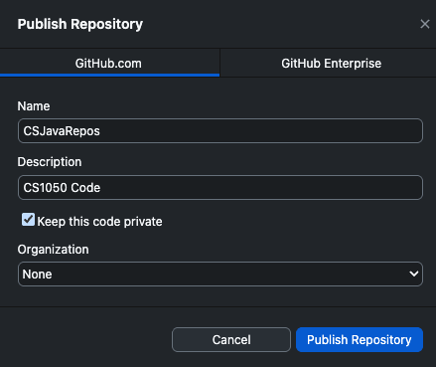

Click Publish
- Do not commit and go to part 2.

Part 2: Ignore files that shouldn’t be backed up
In this part, you will edit the .gitignore file on the Github Remote Cloud Server and then fetch and pull the changes to your local git repository on your computer.

- Go to your repository on the github server
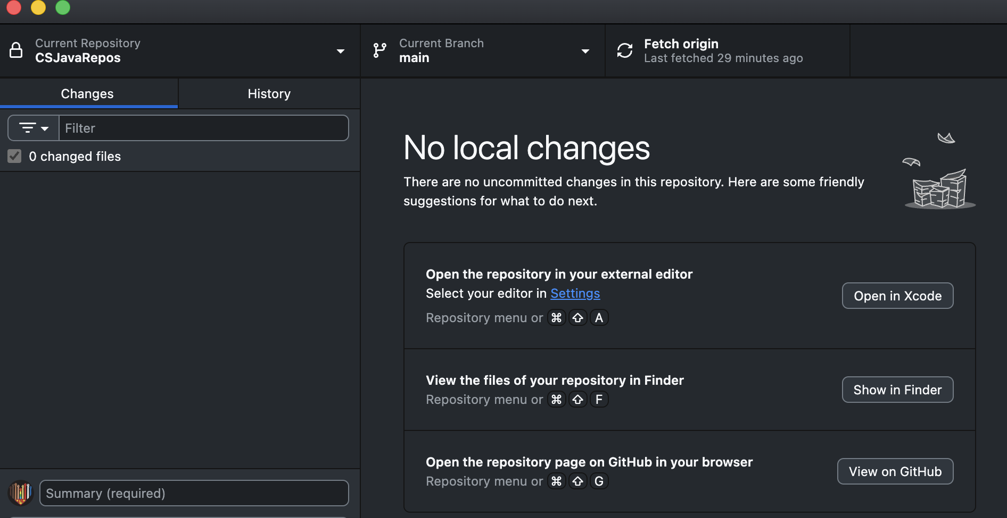

- Click the .gitignore file in your GitHub Cloud Repo and click to pencil edit icon
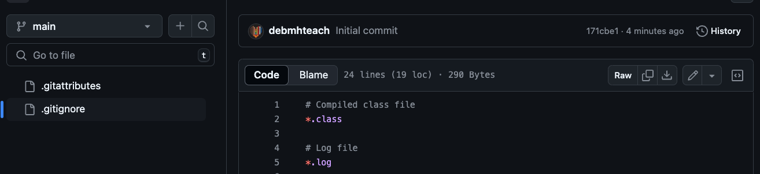

- Delete what is currently in the .gitignore. Copy and paste the content below into the .gitignore.

#######################
# MSU Denver CS1050 / CS2050
# Java + Eclipse (Teaching Repository)
#######################

#######################
# Java / JVM
#######################
*.class
*.log
hs_err_pid*
replay_pid*

#######################
# Eclipse (keep project files so import works)
#######################

# Keep these tracked so Eclipse imports cleanly on any computer
!.project
!.classpath
!.settings/
!.settings/org.eclipse.jdt.core.prefs
!.settings/org.eclipse.jdt.ui.prefs

# Ignore Eclipse workspace cruft (never belongs in a repo)
.metadata/
.recommenders/
.loadpath
.externalToolBuilders/

# Ignore build outputs
bin/
out/
target/
tmp/
*.tmp
*.bak
*.swp

# Ignore launch configs (often machine-specific)
*.launch

#######################
# OS cruft
#######################

# macOS
.DS_Store
.AppleDouble
.LSOverride
Icon
._*

# Windows
Thumbs.db
ehthumbs.db
Desktop.ini

- Click commit and then click commit changes
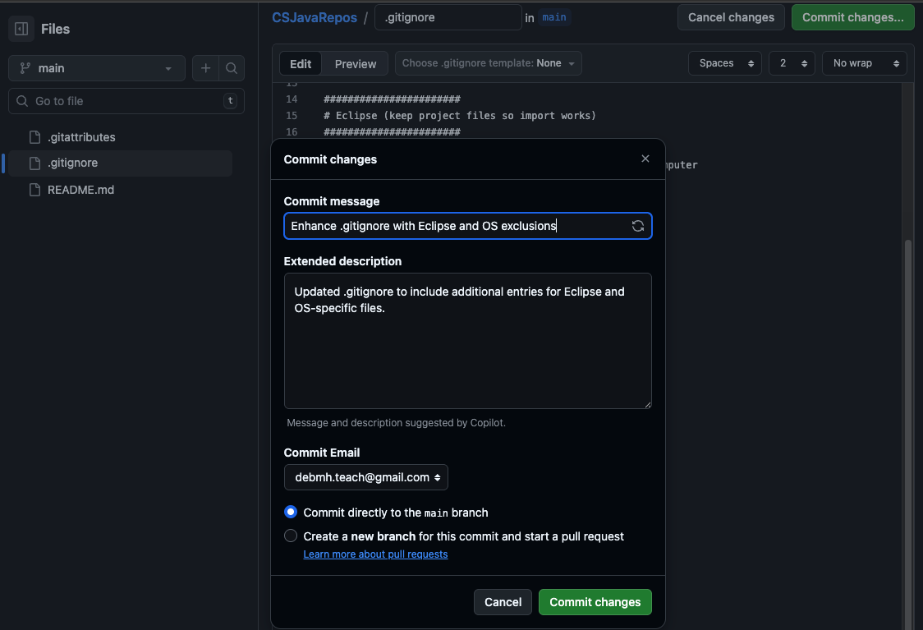

- Go to your repository on the github remote server to see the changed file and two versions. Click history
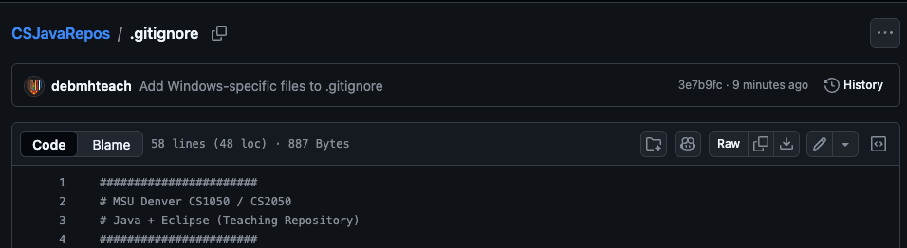

Both version are stored
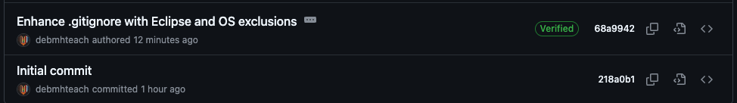

- Fetch and then Pull Origin Go back to your github desktop and you will need to fetch and pull origin to download the updated file to your local computer.
  - Click Fetch Origin
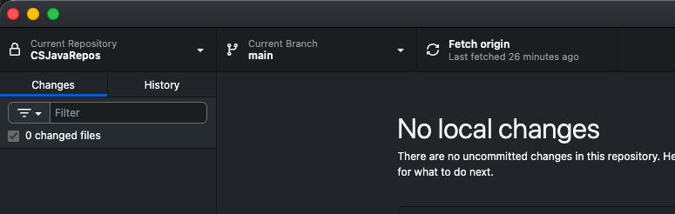

  - Click Pull Origin

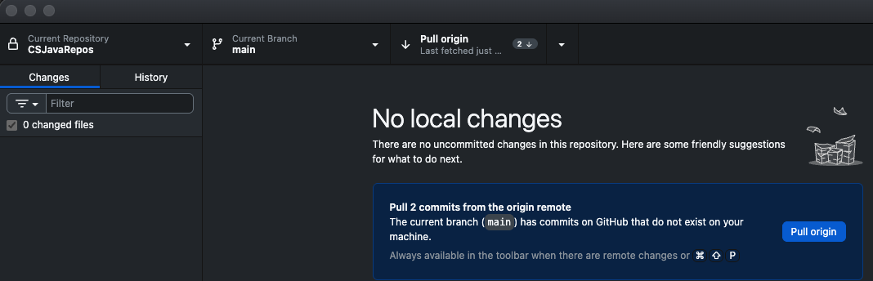

- Do not open the repository with your external editor. You will manage your files in this class with the Github desktop so you can understand the different git commands. Show your files locally on your machine.
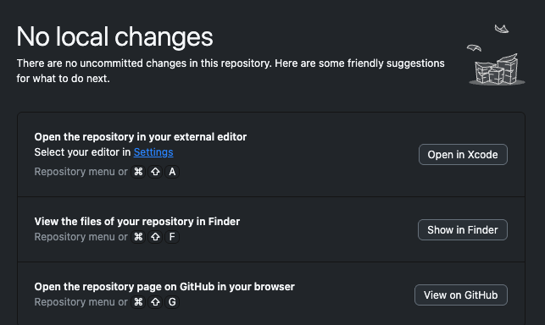

Can configure later to open Eclipse
Go to files stored locally on your computer
Go to files stored on github cloud server
Click to show your files on your local computer and you will see the following. If you do not see the .git information follow instructions to reveal hidden files.
- Mac: Mac Show File Extensions and Hidden Files
- Windows: View hidden files and folders in Windows - Microsoft Support

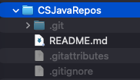

- Click View on Github to see the repository was pushed to your cloud GitHub server.
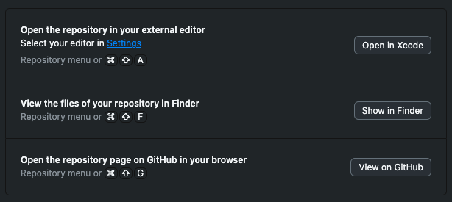

Now you will see the files on the github server.
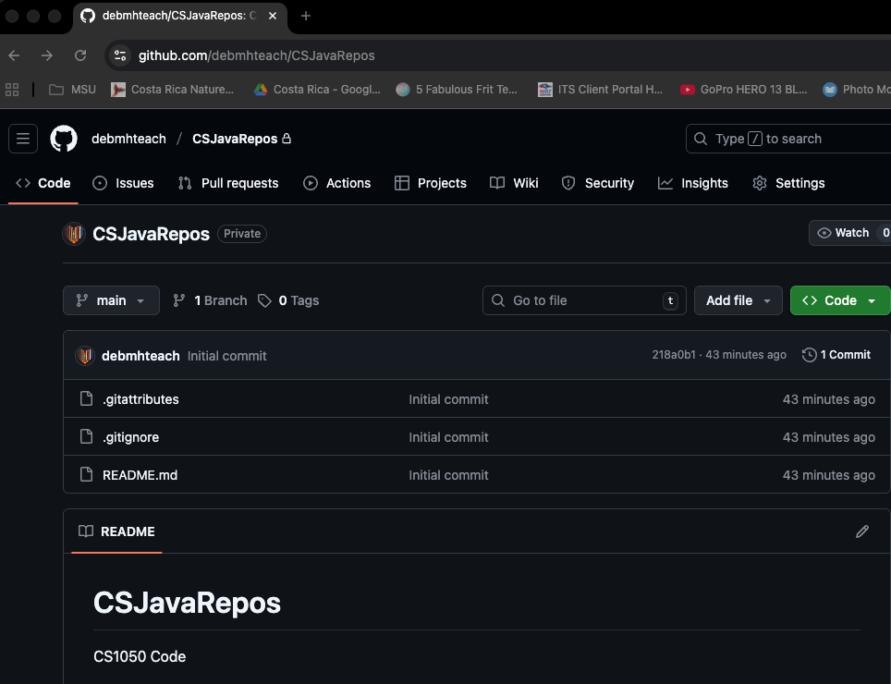

Part 3: Organize in Folders
In this part, you will create different folders to store work. It is important the information is stored in your repo on your local computer and backed up on GitHub Cloud Server. You can add more folders but you should at least have these set up. The only thing you should not store in these folders are large files such as videos, audio, or install apps here.
- Assignments - Assignment documents you will be working on and submitting.
- Tech Docs - various tech docs that are already created or that you create
- Class Resources - Keep any resources such as class documents or powerpoints
- EclipseWorkspace - (No Spaces) This will be where you organize your files in Eclipse project folders after you set up Eclipse
From your github desktop click to show your local git repo folder and add these directories: Assignments, Tech Docs, Class Resources and EclipseWorkSpace.
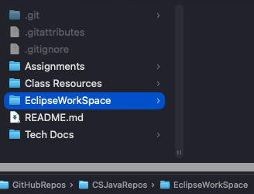

- Download this document and put it in your github repo Tech Docs folder.

Git and GitHub Resources
Remember:
- Commit and Push often
- Version all code and assignments

❓Having issues with GitHub Desktop?
- My local changes aren’t showing up on GitHub? Commit and push?
- Updates on GitHub.com, how do I get that version locally? Fetch + Pull
Here is more information:
- CS-2-Community-HUB/github_desktop_guide.md
- GitHub Desktop documentation

